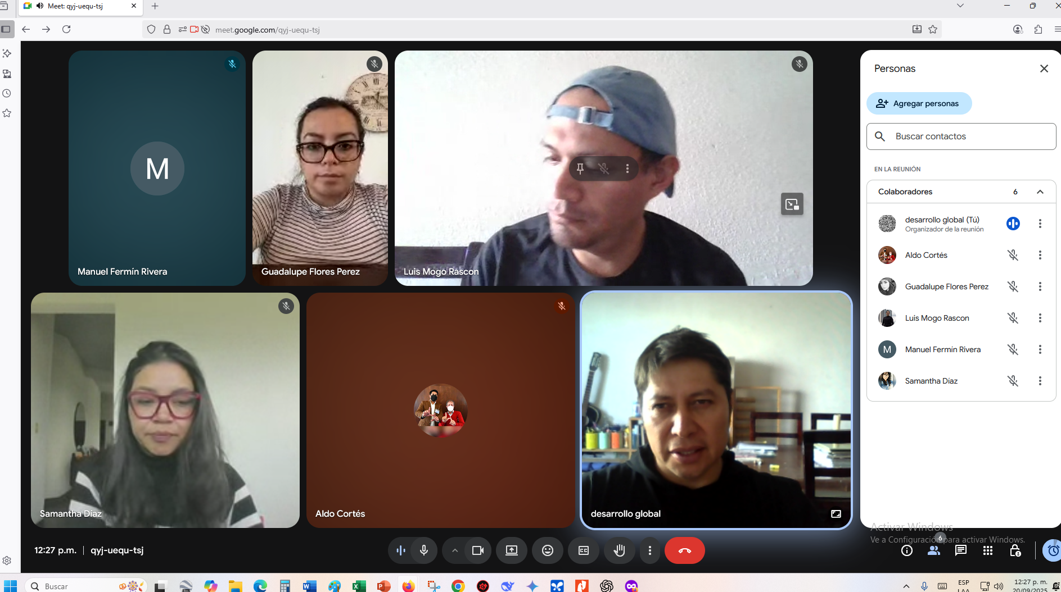

Luis (2)
Aldo (2)
Samantha(2)
Manuel (2)
Gdualalupe (2)
dennis

